# **Exposure**

Now that you are familiar with the basics of the camera and fundamentals of composition, it is time to put what you are learning together.

**Exposure** refers to the relative darkness and lightness of a photograph. As photographers, we are concerned first with correctly capturing the brightness level of whatever we are photographing. A properly exposed photograph will convey to the viewer how bright or dark the scene really was. We use our digital camera’s light meter to create a properly exposed picture, but it is important to understand the foundation of exposure so you can use this to your advantage and create dramatic and powerful images without relying on filters or image editing software.

|  |  |  |
| --- | --- | --- |
| **Underexposed Photograph** | **Properly Exposed Photograph** | **Overexposed Photograph** |
| Photograph showing  Underexposed Photograph of Adler Planetarium. | Photograph showing Properly Exposed Photograph of Adler Planetarium. | Photograph showing Overexposed Photograph of Adler Planetarium. |
| Photograph showing Underexposed Photograph of Century Link Field. | Photograph showing Properly Exposed Photograph of Century Link Field. | Photograph showing Overexposed Photograph of Century Link Field. |

There are **three** variables which work together to affect the proper exposure:

1**. ISO**. ISO is the common short name for the International Organization for Standardization. ISO is the degree of sensitivity of the camera to available light. This is called the ISO, and is expressed in numbers. The higher the ISO number, the more sensitive to light (the less light is necessary to make an image). Why not always use a very high ISO then? Because very high ISOs come at a cost-- they do not record fine detail as well, they introduce false information --called noise-- which degrades the image quality. It is true that image editing programs can reduce noise, but your image deteriorates as you do this, as does sharpening.

2. **Aperture.** The size of the opening of the lens is called its aperture. This is expressed in numbers and is also called f-stops. The smaller the number the larger the opening, the more light is received by the sensor. The higher the number, the smaller the opening, the less light is received by the sensor. The aperture controls the Depth of Field of an image. Depth of field is the distance between the nearest and the furthest objects that give an image judged to be in focus in a camera. It is basically the range of sharpness in an image, from foreground to background.

3. **Shutter speed.** The shutter opens and closes according to a predetermined duration we can set, and is expressed as a fraction of a second. The longer the shutter stays open, the more light it admits. The faster the shutter moves, the less light it admits.

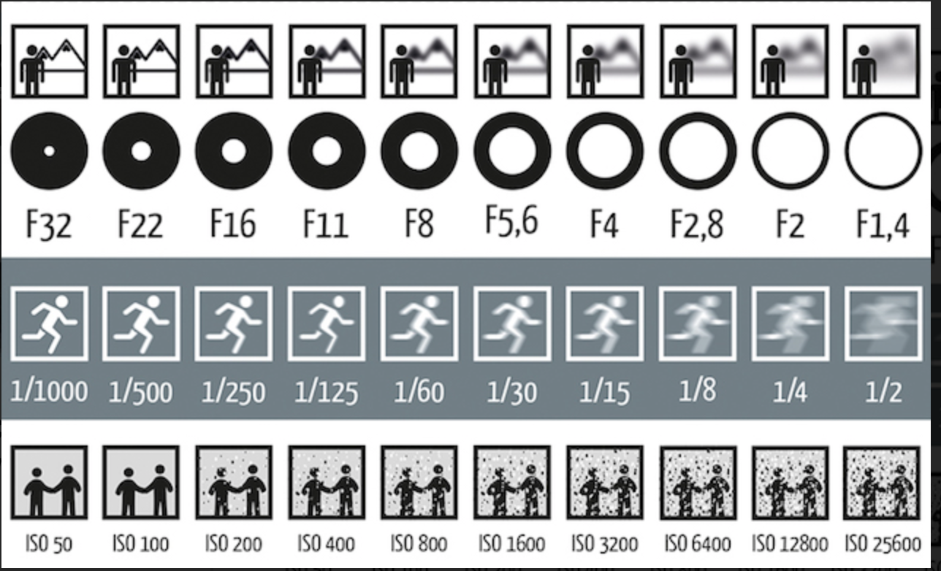

## Putting it All Together

All three of these variables are in play every time we take a picture with our cameras, and changing any one of them causes the need for a change in another one. This is a good thing, because it allows us some flexibility to choose what is important in our picture.

For example, if we wish to freeze a subject moving quickly we must use a very fast shutter speed. But that will require some adjustment in either or both the aperture and ISO. Typically, it means we select a larger aperture and/or a higher ISO rating.

On the other hand, if you need subjects both close and far away to be in focus in the same shot you need a great deal of Depth of Field (also called, depth of focus). That can only be made by using a very small aperture (a larger number), but it will require either or both of a longer shutter opening duration (a slower shutter speed) and a higher ISO. This week you will create a photograph using a wide-open aperture to create a shallow depth of field and take the same photo with a closed aperture to create maximum depth of field.

|  |  |
| --- | --- |
| **Photo with Maximum Depth of Field** | **Photo with Shallow Depth of Field** |
| A Photograph showing Maximum Depth of Field of the streets of Chicago. | Photograph of a young boy, showing the Shallow Depth of Field. |

## The Sunny 16 Rule

While digital cameras allow for auto settings, one rule that is important to know is called the Sunny 16 Rule. This is a great way to understand how exposure really works.

Imagine you are out on a sunny day and you were given a manual only camera. How would you take a picture with the proper exposure? Think it would be impossible? Not at all. Here is the rule.

1. Put your ISO at 200
2. If it is sunny, set your aperture at F/16.
3. Set your shutter-speed to the nearest setting that matches the ISO. If your ISO is 200, set your shutter at 1/250

This is how you create a picture without a light meter in your camera. As long as you keep your ISO on the same setting, you can modify the aperture and shutter speed.

The table below shows variations on the Sunny 16 Rule where you keep the ISO paired with the nearest shutter speed.

|  |  |  |  |  |
| --- | --- | --- | --- | --- |
| **ISO** | **Shutter Speed** | **Aperture** | **Lighting conditions** | **Shadow detail** |
| 200 | *1/250* | *f*/22 | Snow/sand | Dark with sharp edges |
| 200 | *1/250* | *f*/16 | Sunny | Distinct |
| 200 | *1/250* | *f*/11 | Slight overcast | Soft around edges |
| 200 | *1/250* | *f*/8 | Overcast | Barely visible |
| 200 | *1/250* | *f*/5.6 | Heavy overcast | No shadows |
| 200 | *1/250* | *f*/4 | Open shade/sunset | No shadows |
| 200 | *1/250* | Add one stop | Backlighting | n/a |

## Low Light

If you are shooting in relatively dim lighting conditions and do not want to use a flash, you will need to use a high ISO rating, and quite probably also a large aperture and a slow shutter speed.

## Camera Stabilization

Part of being human involves movement. Our pulse, breathing, and muscles do not stay still, so for our own bodies not to make our pictures blurry, we need to use a minimum shutter speed of around 1/60th of a second. 1/125 second is more ideal.

Some folks can hand-hold with no blur down to 1/30 second, but it becomes difficult. Below 1/60th second it is recommended to use a tripod to keep the camera steady. Using a camera lens with a longer focal length, such as a telephoto increases the sensitivity and requires the use of a tripod. Tripods are important tools and can be simple or very complex. Monopods are also very helpful.

In any case, get used to holding your breath when you shoot, and, to smoothly and gently depressing the shutter button. Don't jab at it or stab at the shutter, squeeze it and hold it down until the picture is taken.

## White Balance

Digital sensors react to different sources of light differently. Although our eyes cannot detect much difference sensors see colors from the light source we cannot. For example, light from tungsten bulbs carries extra yellow the sensor will record; daylight in shadow appears extra blue; fluorescent light bulbs have a heavy green cast. We can filter out those color casts by adjusting how a white object is depicted in our photographs.

White balance is a term that refers to the overall color cast a digital image has. To arrive at a neutral color cast where the colors of things look like they do in the world we look at how white objects appear in the photograph. You should adjust that in the camera for different lighting conditions, choosing white balance that corresponds to your lighting. Auto white balance can only go so far. You can correct white balance using image editing software if you didn't make the right adjustment to the camera.