# **Depth of Field: Demystified**

The concept of aperture (f-stop), lens focal length, and depth of field can be confusing when you are first learning about camera mechanics. Sometimes it is helpful to think about it in a new way. As you learned in the lecture on exposure, the aperture (F-stop) controls the Depth of Field of an image.

## **Aperture - Need to Know:**

* Aperture and F-stop may be used interchangeably.
* The number engraved on the lens indicates the relative aperture, which is computed by dividing the focal length of the lens by the diameter of the opening.
* The higher the number the smaller the hole.
* The lower the number the larger the hole.
* Each F-stop is exactly double the amount of light. F-5.6 = 2 x F-8
* The F-stop controls Depth of Field.

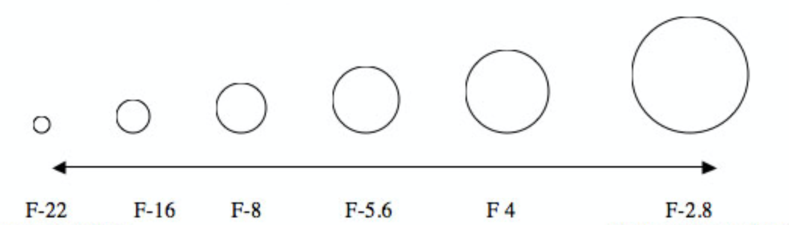

Depth of field is the distance between the nearest and the furthest objects that give an image judged to be in focus in a camera. It is basically the range of sharpness in an image, from foreground to background.

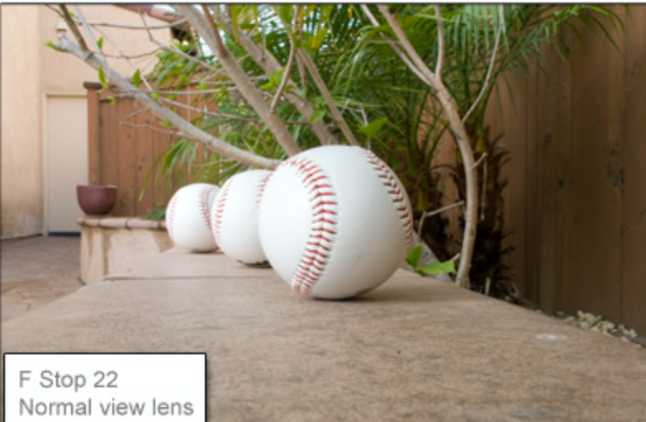 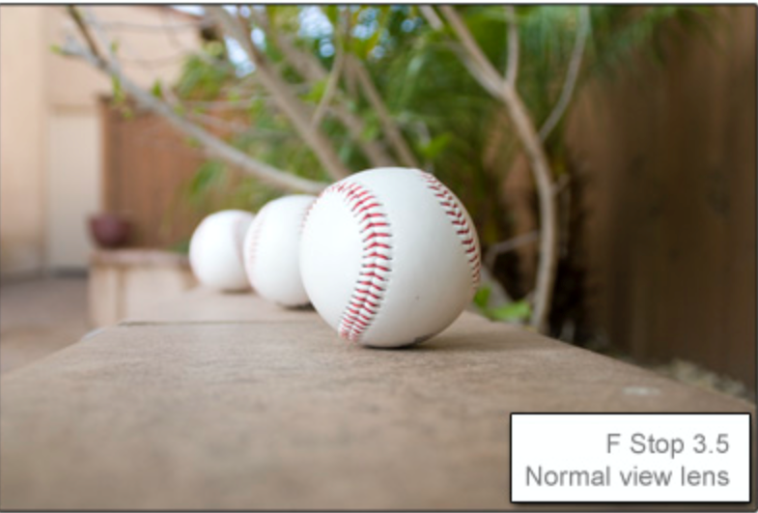

## **A Different Angle on Depth of Field**

Let’s explore a scenario in which you want to take a picture of people that with different ranges of sharpness from the foreground to the background. Imagine you are standing under the goal post at one end of a football field, facing the far goal post. There is one player standing on each of the yard lines all the way from the first line right in front of you, down the field to the opposite end goal line.

### **Scenario One: Shallow Depth of Field**

If you want only the player standing exactly mid-field to be in focus, and you want all the other players in front of him and behind him to be blurry, you want a very **shallow** depth of field. You choose a **wide-open** aperture, such as **F 2.8.** You adjust the lens focus so he or she is sharp and adjust the shutter speed accordingly. Using a camera’s aperture priority mode is a great way to do this.

This is true also no matter which player you want to be the one in focus, as long as you want the others behind and in front of him to be blurry. Use a wide open F-stop, and use the lens to focus only the person you want to be sharp. This could be any guy on any of the lines anyplace down the whole field, and anybody in front or behind him will be out of focus.

### **Scenario Two: Maximum Depth of Field**

Now what if you want the person at exactly mid-field to be sharp, and you also want people standing behind him/her and in front of him/her to be in focus? For this you would need maximum depth of field. To do this, you would select **a small/closed** aperture such as **F 16**. You would still focus the lens on the person mid field, yet by having chosen a small aperture this time, you get a greater depth of field, and people standing behind and in front of him/her are still in focus. Again, you need to adjust the shutter speed accordingly and using a camera’s aperture priority mode is a great way to do this. With small apertures, you are letting in less light, so chances are you would need a tripod to allow a longer shutter speed to compensate for the reduction in light.

This is the **basic** principle behind Depth of Field regardless of camera or lens. The only thing that needs to stay the same is the ISO for both shots.

Wide angle lenses have by their nature a greater depth of field than telephoto lenses do. So (assuming the f-stop is the same in both cases) that will influence the depth of field you ultimately capture with your camera.

## **Differences between Wide Angle and Telephoto Lenses**

When you are first exploring Depth of Field, use the same ISO and lens. Wide angle and telephoto lenses work similarly with Depth of Field, yet there are subtle differences between lenses of extreme focal length difference.

Shooting the same football scene with a wide-angle lens (such as 28mm) will make it appear as though the distance between you and the players is greater than it looks with the naked eye, while shooting the exact same scene with a telephoto lens (such as 200mm) will make it appear as though the distances between you and the players has shrunk. The telephoto compresses the space, while the wide-angle expands it.

Consider the football field again. Wide-angle lenses make it look like the field is unusually long and angles may be bent or curved. The players will appear to be farther apart and smaller in the frame. With telephoto lenses of 200mm and higher, the same players appear to be standing very close together. The best way to explore this is by taking pictures and experimenting with the lens and paying attention to what you see in the camera.

Keep in mind, this distortion is not the same as Depth of Field. Depth of Field has to do with where the focus and sharpness of the image is. Lens focal length affects how long or short the distances between things **appear** to be.

