ARTS 152: Digital Photography

Image Submission Guidelines
All photos must be taken after the start of class. Image dates are verified through the metadata embedded in the image's data file. This is NOT a date stamp. Date stamps MUST be turned off. It is the student's responsibility to make sure their camera's date is accurate.
Assignments must be submitted in the drop boxes as JPG files in accordance with file upload instructions as detailed below.
Every camera’s pixel dimensions are different, so remember to constrain proportions when resizing and your image will retain the original aspect ratio.
- JPG in RGB or Grayscale format
- Save 2 copies of each image:
  - Discussion Board Critique no more than 500 pixels in length or height at 72ppi
  - Drop box images more than 1000 pixels in length or height at 72ppi
- File size should be under 4MB
- Do not crop your photographs to a square. Use the same proportion as the camera.
- Always select constrain proportion when resizing.
- Rename the file for the proper assignment as indicated in Content.
Note: Add Yourname (last name) to the filename.
Only .jpg files are accepted.
No .psd, .pdf, .tiff, .png, .doc etc. will be accepted or graded

Resizing Images
The EASIEST way to resize images is to use http://www.picresize.com

Support Tutorials:
If you use Photoshop, follow this tutorial: http://www.screencast.com/t/NjYyYjg5NT
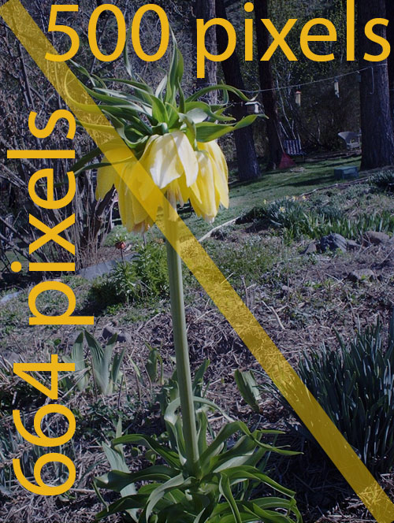
If you use picresize.com, follow this tutorial: http://www.screencast.com/t/NGIwZDUxYzMt

Discussion Board Best Practices
When you are posting images to the discussion, the best practice is to resize your images so they will fit within the discussion window.
I suggest a pixel dimension of 500 pixels for the horizontal dimension and let the vertical side constrain to natural proportions, or 500 x 664 as in this example. Your image’s height will vary, depending on your camera’s aspect ratio.

Pic Resize
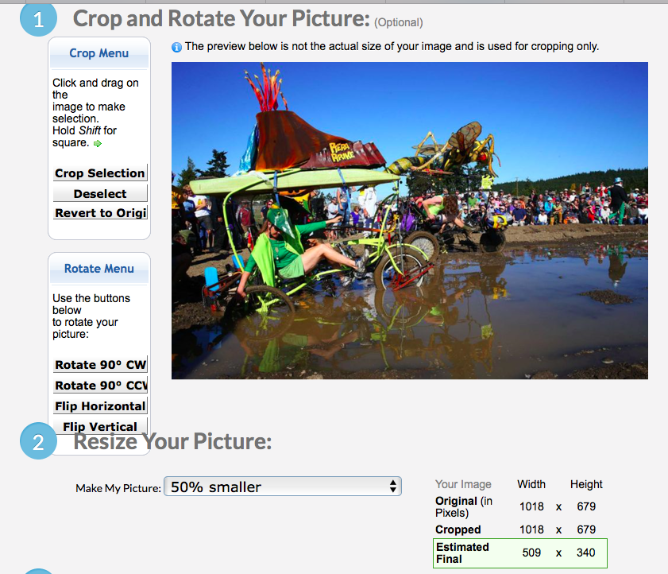
If you use Pic Resize always leave the original pixel proportions.

Image Editing Programs
You can take advantage of the student discount for Photoshop for less than $10 /month
http://www.adobe.com/creativecloud/buy/education.html
There are free programs available:
Gimp: https://www.gimp.org
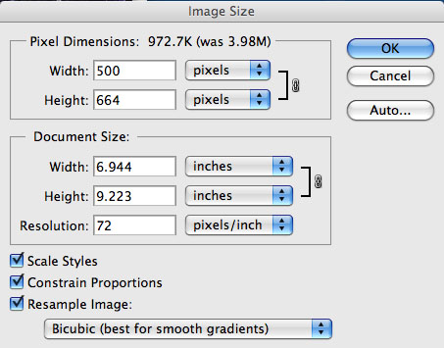
Irfanview: http://www.irfanview.com
If you use an image editor, like Photoshop elements, or Gimp
you have more room for error.
Note that the resolution is set to 72. This is the resolution that computer screens display pixels at. If your resolution is set higher, your image will be much larger.
After you resize, check your view. Make sure you view your image at 100% on screen. With Photoshop, it will appear small, but may be only displaying at 15%.

